Data 604 Final Project

restaurant simulation

Christophe Hunt

Contents

Background 2

Structure 3

Flowcharts for Modeling 5

Verification and Validation Methods 6

Results for Status Quo and Interventional Model 9

Comparison of Results via Statistical Methods 11

Conclusion from the modeling 13

Lessons Learned 14

Appendix 16

Simio Models 16

Presentation 16

YouTube Link of Presentation 16

Table of Figures 17

Bibliography 18

# Background

Customer dissatisfaction is a major concern within the service industry and can impact financial success. For restaurants, the goal is to serve as many customers as quickly as possible, with exceptional service and in a perfect world, every customer could be seated as they arrived at the restaurant. However, we do not live in a perfect world and customers typically wait for extended periods of time before they are seated and served. The longer the wait the more dissatisfied the customer becomes which impacts their experience and reduces the likelihood of repeat business, lowers their purchases/tips, all of which also reduces staff morale[1]. Essentially there are cascading negative effects when customers have long wait times with many balking once the queue is too large and only the trendiest or highest rated restaurants can survive with long customer queues[2].

There are two options for processing customer arrivals, one is to seat customers on a first come first serve basis, and the other is to have a reservation system. Seating customers as they arrive has the advantage of optimizing seating space, but the queue can grow quite large since customers can only know if they will be seated once they arrive at the restaurant. The reservation system has the benefit of customers being seated as soon as they arrive but there will be no-shows and last-minute cancellations that leaves empty tables and lost revenue. However, research has shown that in some cases the average mean revenue per person is higher for reservations compared to walk-in guests[3]. No single perfect system exists but our simulation will consider the performance of a restaurant with a no reservation policy and an intervention of a reservation only policy.

# Structure

In the simulation we will make some assumptions about our customer’s behavior. Customers arriving alone “Customer_1” will typically sit at the “Bar”, Customers arriving in pairs “Customer_2” will be seated at a two-person table “Table_2” even if room exists at either the “Bar” or another table, Customers arriving as a party of 4 “Customer_4” will sit at the table for 4 people “Table_4”. A limitation of this analysis is that a server would have the ability to combine tables to accommodate the arriving customers to maximize efficiency, if Simio could provide this accommodating it would be interesting to see if the server should or shouldn’t combine tables based on the arrival rates for this type of restaurant.

Since I do not have access to actual customer counts, arrival rates, or dining times, I will be using figures provided by others with research in this area and will adjust for this simulation. Using the restaurant modeled in “Case Study for Restaurant Queuing Model”[4], we’ll assume a restaurant with 15 tables, 10 tables for groups of 4, 5 tables for pairs and 5 seats at the bar. We will also assume 6 waiters and waitresses are working at any time and there are 400 customers on weekdays and 500 on each weekend day[5] during the dinner rush. We will model the weekday dinner rush, for a time of 4-hour time span from 6 pm to 10 pm and then add 100 customers for the extra hour in our model for 500 customers in total each day. The distribution of arriving groups is 60 groups of 4 (240 people, 35%), 50 groups of 2 (100 people, 30%) and 60 individuals (35%). Further, people will begin to balk at ~36 people [6] so we’ll extrapolate that to 12 groups of any kind of combination (*Lq*). A more robust model may accommodate the differences in group sizes and adjust accordingly.

* *Λ* = 500/240 = 2.08 customers/minute
* *Wq* = 36 customers/2.08 cpm = 17.31 minutes

Our dining times will follow the distribution provided in “Restaurant Table Management to Reduce Customer Waiting Times.” which follow a uniform distribution of 40 to 45 minutes[7] (*W*). A more robust model may accommodate a different dining time for different groups, my assumption is that those arriving alone would likely dine faster than those in a large group. Therefore, the average number of people in the restaurant is L = 2.08 cpm * 45 minutes = 93.6 customers and the utilization rate μ = (2.08 * (1+93.6))/93.6 = 2.10 cpm.

I was unable to locate an average cooking time for a meal from customer order to out of the kitchen. Assuming the average time in the restaurant is 40 to 45 minutes, we’ll be assuming that it is a uniform distribution for 20 to 25 minutes per table order.

The cost per person for the walk-in model will be a uniform distribution between $42 and $74 whereas the revenue per person will be between $47 and $79 for the reservation guests which follows the restaurant model from “Restaurant Revenue Management” [8] that shows reservation guests will pay more than walk-ins. Since these per group dollar values include tip, we will presume it translates to a wage of $15 for each staff member.

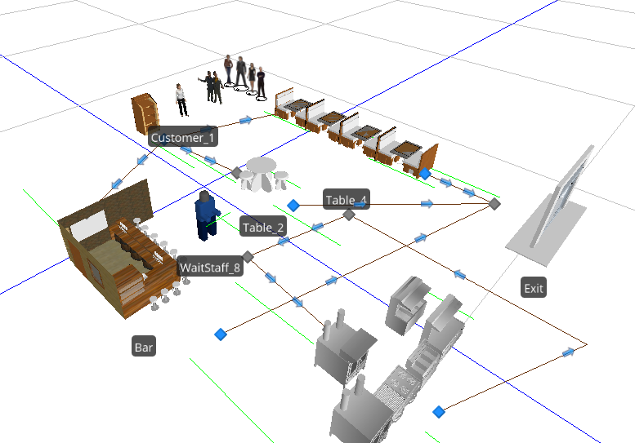

Figure 1- Model Layout

# Flowcharts for Modeling

The flow is a standard restaurant service flow. The customer types arrive at the restaurant and then are first greeted by a host. The host performs multiple tasks at this station, they check for available seating, in our intervention model they will check for appointments, then they seat customers in the preferred order. They essentially act as the gatekeepers to the restaurant. Once seated the wait staff work with the customer to determine their order, then they take that order to the kitchen to prepare, after the order is completed the wait staff return the food to the customers. Many other smaller tasks occur between these larger steps but are out of scope for this assignment and add undue complexity. Then after the customers have enjoyed their meal they pay and exit the restaurant.

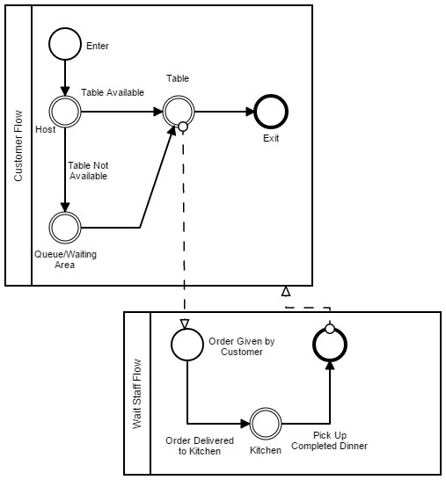

Figure 2- Workflow

Possible improvements on the flow include a re-work path for returned meals for varying customer preference issues such as over seasoned, under seasoned, overcooked, etc. The re-work path would need to accommodate that the meal would have to be moved to the front of the queue or a similar meal in process would need to go to the customer returning the meal.

# Verification and Validation Methods

Our initial run appears to follow closely with the figures we determined at our structure set up.

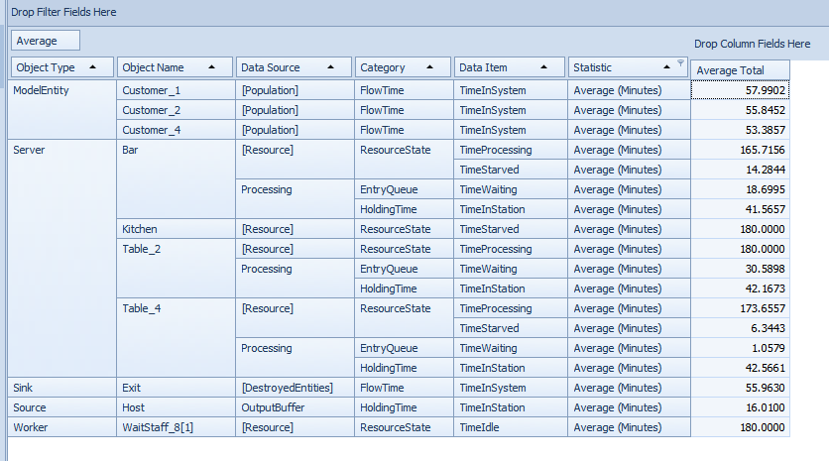

Figure 3- Original Validation Results

The average wait time during the three-hour period is 16 minutes and we were hoping to model a 15- minute wait. In our intervention model, the wait time should at most be 5 minutes. We wanted to have an entire time spent in the restaurant to be approximately 45 minutes, the average time of 53 to 57 minutes is within an acceptable range. The major concern is the difference in wait times between the three groups. Our 4-person group waits nearly no time at all, with our bar customers waiting 20 minutes and our group of 2 waiting nearly 30 minutes. To achieve a more balanced wait time we adjusted the number of tables as follows, 5 4-person tables, 5 2-person tables, and 5 1-person spots at the bar. The restaurant is at full capacity with 35 people.

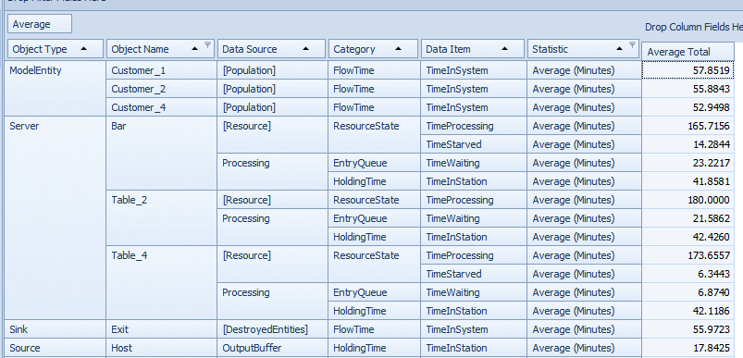

Figure 4- Validation with adjusted table numbers

While our wait times were more balanced our actual customer throughput is considerably under the total we initial considered at 112. Therefore, we adjusted the table counts up to 6 4-person tables, 7 2-person tables, and 8 1-person spots at the bar. The restaurant is at full capacity with 46 people, however, we only processed 211 customers for the entire time-period.

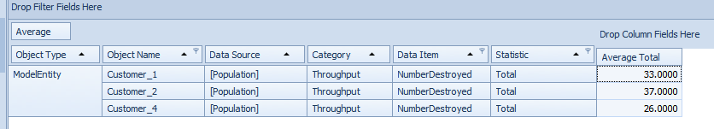

Figure 5- Validation of Customer Counts

Since our primary objective is to understand how wait times, more without a reservation and less with a reservation, we will forgo the validation of the customer counts and continue with this table set up since we see normalized wait times by customer type. Anecdotally, my experience has been I could sit at the bar immediately or can wait for a table that falls within normal table as seen in the table.

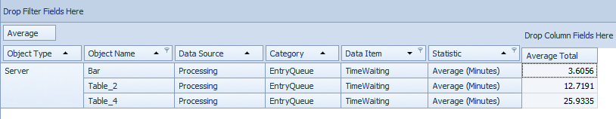

Figure 6 - Validation of Wait Times

# Results for Status Quo and Interventional Model

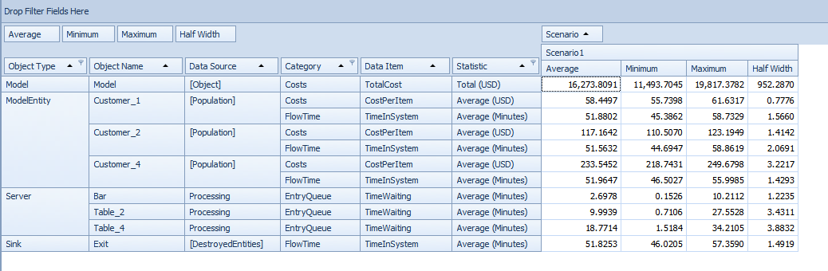

Figure 7- Status Quo Simulation Results

The results are in line with our expectations, the wait times for the different seating options appear realistic, short wait times for the bar with longer wait times for 2-person and 4-person tables. Our total daily weekday revenue is approximately $16,273 which equates to $325,000 for an average month.

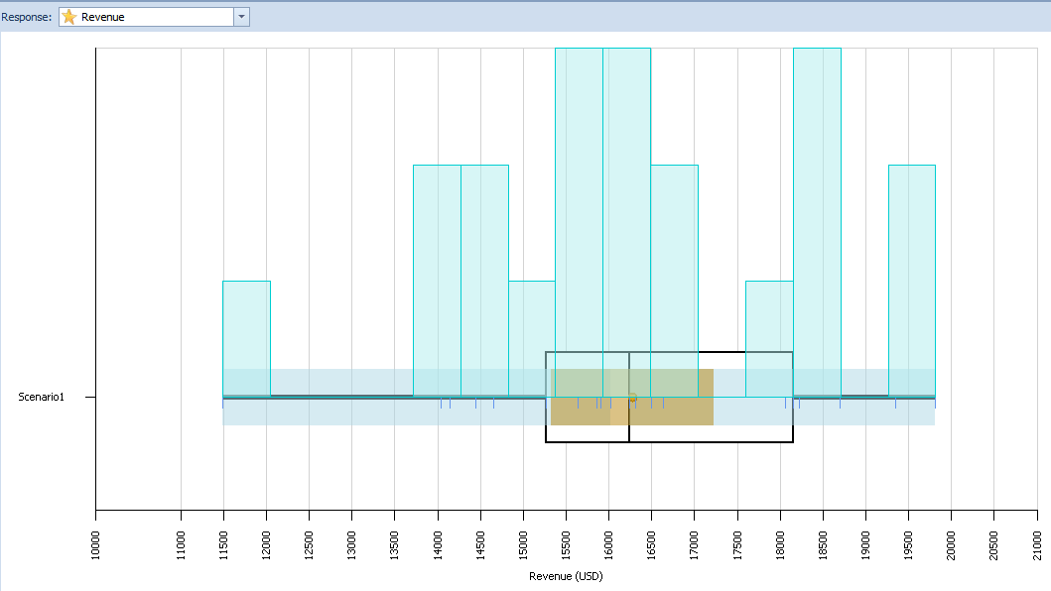

Figure 8 - Revenue from Status Quo model

Also, a primary concern is the number of groups that have balked at the proposition of waiting too long for a table. Here we see that approximately 5 groups balked at the waiting queue. Although, an average waiting time of 10 minutes is not long to wait but we assume that the sight of such a long queue is sufficient for people to not enter the queue.

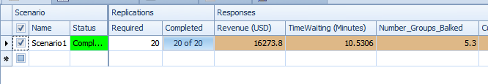

Figure 9- Status Quo Balk Counts

For the intervention model, we will adjust the uniform distribution of the revenue per group and instead of groups balking we will need to account for cancellations. The probability of a cancellation is between 9.07% and 12.95%[9] which we set as a process in Simio and tally the cancellations.

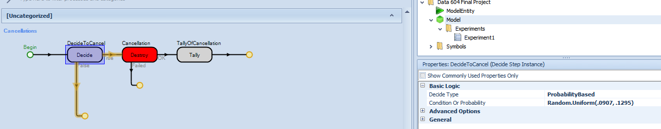

Figure - Cancellation Process

We further set the output buffer capacity to 0 as we assume that all customer arriving will be seated as they arrive, and the add-on process is set for created entities. The per guest revenue is also adjusted for a uniform distribution between $47 and $79.

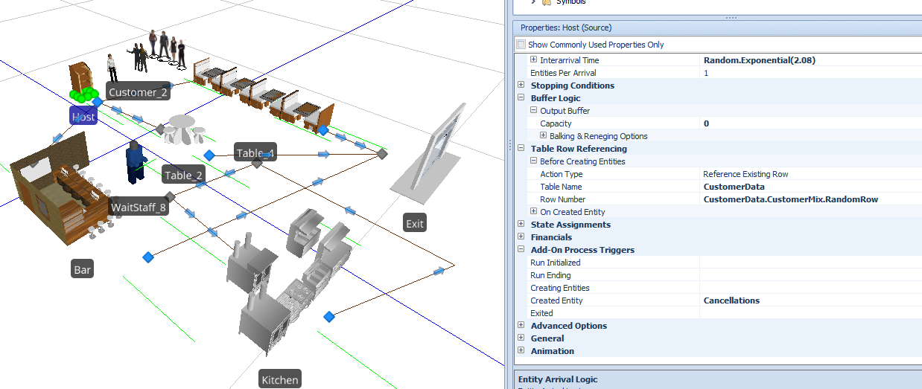

Figure - Cancellation Setup in Intervention Model

Since we assume that without cancellations we would be at 100% capacity we need to verify the effects of the cancellation rates on our utilization percentage. It is consistent with our expectations of cancellations.

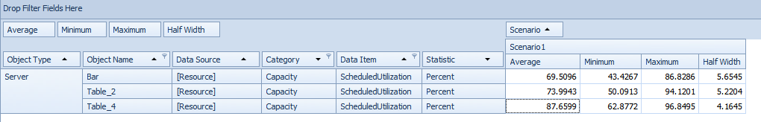

We resume our experiment for the intervention model with the same number of repeats of 20 simulations for an average month.

# Comparison of Results via Statistical Methods

The results of the status quo model show an average revenue of $16,273, with an average waiting time of 10.53 minutes, and an average of 5.3 groups balking at the length of the queue.



Figure - Status Quo Final Results of Simulation

The revenue distribution for the status quo model is provided in the following figure.



Figure - Average Revenue Distribution of Status Quo Model

The results of the intervention model show an average revenue of $17,481, with 0 minutes of waiting time (intentional), and an average of 12 groups cancelling their reservation.

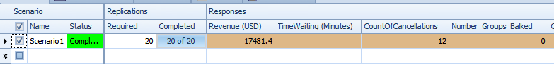

Figure - Intervention Model Final Results

The revenue distribution for the intervention model is provided in the following figure.

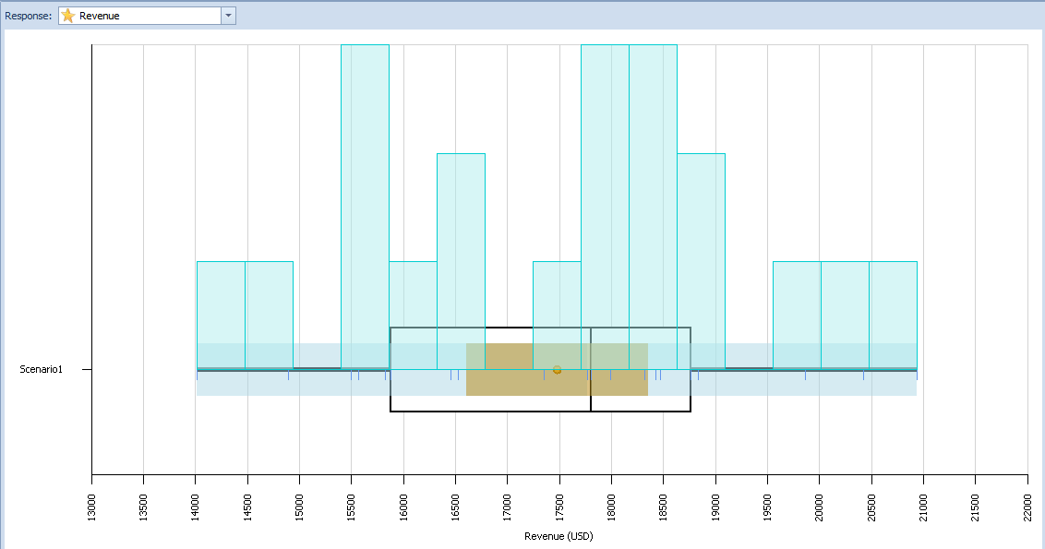

Figure - Average Revenue Distribution of Intervention Model

However, after conducting a t-test on the means of revenues for the status quo and the intervention, we see that the p-value exceeds .05. Therefore we can conclude that the means are significantly similar, although the p-value is approaching significance.

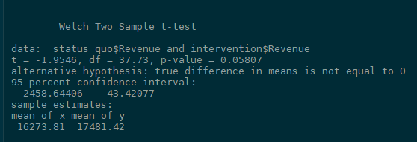

Figure - t-test of revenues

# Conclusion from the modeling

Surprisingly, the reservation method generated the highest revenue which is our focus of interest. I would have assumed that with the cancellations there would be less revenue even with a higher average per customer.

However, based on the research there are many things to consider first before implementing the strategy. If the reservation cancellation rate is less than a uniform distribution of ~9% to ~12% then this strategy may be more acceptable. Although, the reservation system requires significantly more coordination, such as follow up calls to confirm the reservation, managing tables for lingering guests so reservations stay on track, etc. If the staff support is not there to coordinate a seamless experience for the customer than this strategy may not be appropriate under any circumstances.

If our sole objective is increased revenue, and all else is the same then the recommendation would be the walk-in strategy because it requires less effort than the reservation strategy while achieving similar revenue outcomes.

# Lessons Learned

Associated research on restaurant processes is extensive and there are many nuances to consider that are not possible to include in this simulation. I was not able to include the condition of similar restaurants in the area that have a different seating process impacting our results[10]. In that circumstance, we may see quicker balking because more options exist, or we may see increase in traffic because the other restaurant may not be able to accommodate the customer appropriately. Modeling interactions becomes challenging as every possible detail begins to offer some insight into the ability to impact our model but at a substantial cost for set up.

Modeling groups becomes challenging in the context of batch processing. In the restaurant scenario, we cannot necessarily batch arriving customers into efficient groups for our purposes. A party of 4 would be exceptionally upset if they were split into 2 parties of 2 because separate tables were available. However, Simio does not offer a simplistic method to process groups of arriving model entities which would be a required feature of a more robust model.

To have a meaningful model there needs to be a period of data discovery, I had to make many assumptions to create my model. If I did not have many important facts from others who have already completed this type of research I would have been very challenging to create a significant model.

Overall, my greatest take away is that properly scoping out the simulation is one of the most important objectives. There are many details that can impact the model but there needs to be a guiding principal on what detail is important and what is simply noise that does not add value.

# Appendix

## Simio Models



## Presentation



## YouTube Link of Presentation

https://www.youtube.com/watch?v=6mLbff1yGVY&feature=youtu.be

## Table of Figures

Figure 1- Model Layout 5

Figure 2- Workflow 6

Figure 3- Original Validation Results 7

Figure 4- Validation with adjusted table numbers 8

Figure 5- Validation of Customer Counts 8

Figure 6 - Validation of Wait Times 9

Figure 7- Status Quo Simulation Results 9

Figure 8 - Revenue from Status Quo model 9

Figure 9- Status Quo Balk Counts 10

Figure 10 - Cancellation Process 10

Figure 11 - Cancellation Setup in Intervention Model 11

Figure 12- Status Quo Final Results of Simulation 12

Figure 13- Average Revenue Distribution of Status Quo Model 12

Figure 14 - Intervention Model Final Results 12

Figure 15 - Average Revenue Distribution of Intervention Model 13

Figure 16 - t-test of revenues 13

## Bibliography

Dharmawirya, Mathias, and Erwin Adi. “Case Study for Restaurant Queuing Model.” *SSRN Electronic Journal*, 2012. https://doi.org/10.2139/ssrn.2014470.

Gregorash, Bill J. “Restaurant Revenue Management: Apply Reservation Management?” *Information Technology & Tourism* 16, no. 4 (December 2016): 331–46. https://doi.org/10.1007/s40558-016-0065-0.

Hwang, Johye. “Restaurant Table Management to Reduce Customer Waiting Times.” *Journal of Foodservice Business Research* 11, no. 4 (December 10, 2008): 334–51. https://doi.org/10.1080/15378020802519603.

Hwang, Johye, and Carolyn U. Lambert. “The Interaction of Major Resources and Their Influence on Waiting Times in a Multi-Stage Restaurant.” *International Journal of Hospitality Management* 27, no. 4 (December 2008): 541–51. https://doi.org/10.1016/j.ijhm.2007.08.005.

Tanizaki, Takashi, and Takeshi Shimmura. “Modeling and Analysis Method of Restaurant Service Process.” *Procedia CIRP* 62 (2017): 84–89. https://doi.org/10.1016/j.procir.2016.06.076.

Tse, Tony S. M., and Yiu-Tung Poon. “Modeling No-Shows, Cancellations, Overbooking, and Walk-Ins in Restaurant Revenue Management.” *Journal of Foodservice Business Research* 20, no. 2 (March 15, 2017): 127–45. https://doi.org/10.1080/15378020.2016.1198626.

1. Hwang, “Restaurant Table Management to Reduce Customer Waiting Times.”
2. Hwang and Lambert, “The Interaction of Major Resources and Their Influence on Waiting Times in a Multi-Stage Restaurant.”
3. Gregorash, “Restaurant Revenue Management.”
4. Dharmawirya and Adi, “Case Study for Restaurant Queuing Model.”
5. Dharmawirya and Adi.
6. Dharmawirya and Adi.
7. Hwang, “Restaurant Table Management to Reduce Customer Waiting Times.”
8. Gregorash, “Restaurant Revenue Management.”
9. Tse and Poon, “Modeling No-Shows, Cancellations, Overbooking, and Walk-Ins in Restaurant Revenue Management.”
10. Tanizaki and Shimmura, “Modeling and Analysis Method of Restaurant Service Process.”